LAB 6(1)
Aim:To design a decoder to recover the BCD representation(DCBA) of a decimal digit from C3 C2 C1 C0 representation(encoded representation)
Components Used:
- Inputs
- NAND gates
- NOR gates
- 4x1 mux
- OR gates
- AND gates
- NOT gates
- Seven Segment Display
- Connecting wires
Link of circuitverse: https://circuitverse.org/simulator/edit/lab-6-a-3e05113e-9b1f-4f0d-8647-7adaedb227d5
Circuit Diagram:
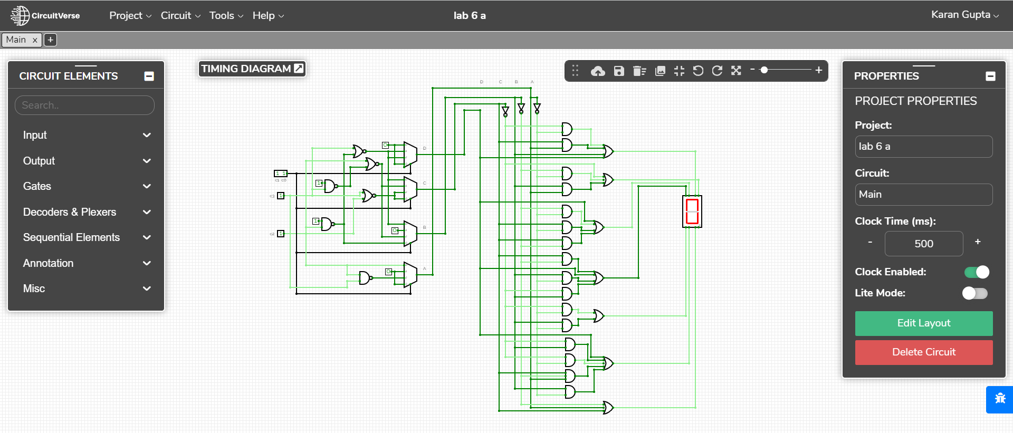
Truth Table(Decoder for decoding code):
INPUT |  |  |  |  | OUTPUT
DEC | C3 | C2 | C1 | C0 | DEC | D | C | B | A
0 | 0 | 0 | 0 | 0 | 0 | 0 | 0 | 0 | 0
1 | 0 | 0 | 0 | 1 | 0 | 0 | 0 | 0 | 0
2 | 0 | 0 | 1 | 0 | 5 | 0 | 1 | 0 | 1
3 | 0 | 0 | 1 | 1 | 6 | 0 | 1 | 1 | 0
4 | 0 | 1 | 0 | 0 | 7 | 0 | 1 | 1 | 1
5 | 0 | 1 | 0 | 1 | 8 | 1 | 0 | 0 | 0
6 | 0 | 1 | 1 | 0 | 9 | 1 | 0 | 0 | 1
7 | 0 | 1 | 1 | 1 | 0 | 0 | 0 | 0 | 0
8 | 1 | 0 | 0 | 0 | 0 | 0 | 0 | 0 | 0
9 | 1 | 0 | 0 | 1 | 4 | 0 | 1 | 0 | 0
10 | 1 | 0 | 1 | 0 | 3 | 0 | 0 | 1 | 1
11 | 1 | 0 | 1 | 1 | 2 | 0 | 0 | 1 | 0
12 | 1 | 1 | 0 | 0 | 1 | 0 | 0 | 0 | 1
13 | 1 | 1 | 0 | 1 | 0 | 0 | 0 | 0 | 0
14 | 1 | 1 | 1 | 0 | 0 | 0 | 0 | 0 | 0
15 | 1 | 1 | 1 | 1 | 0 | 0 | 0 | 0 | 0

Truth Table(BCD to seven segment Decoder):
DEC | D | C | B | A | a | b | c | d | e | f | g
0 | 0 | 0 | 0 | 0 | 1 | 1 | 1 | 1 | 1 | 1 | 0
1 | 0 | 0 | 0 | 1 | 0 | 1 | 1 | 0 | 0 | 0 | 0
2 | 0 | 0 | 1 | 0 | 1 | 1 | 0 | 1 | 1 | 0 | 1
3 | 0 | 0 | 1 | 1 | 1 | 1 | 1 | 1 | 0 | 0 | 1
4 | 0 | 1 | 0 | 0 | 0 | 1 | 1 | 0 | 0 | 1 | 1
5 | 0 | 1 | 0 | 1 | 1 | 0 | 1 | 1 | 0 | 1 | 1
6 | 0 | 1 | 1 | 0 | 1 | 0 | 1 | 1 | 1 | 1 | 1
7 | 0 | 1 | 1 | 1 | 1 | 1 | 1 | 0 | 0 | 0 | 0
8 | 1 | 0 | 0 | 0 | 1 | 1 | 1 | 1 | 1 | 1 | 1
9 | 1 | 0 | 0 | 1 | 1 | 1 | 1 | 1 | 0 | 1 | 1

KMAPS(Decoder for decoding code):
D
_{c3 c2} ^{c1 c0} | 0 0 | 0 1 | 1 1 | 1 0
0 0 | 0 | 0 | 0 | 0
0 1 | 0 | 1 | 0 | 1
1 1 | 0 | 0 | 0 | 0
1 0 | 0 | 0 | 0 | 0
D
^{c1 c0} | 0 0 | 0 1 | 1 1 | 1 0
 | 0 | c3'.c2 | 0 | c3'.c2

C
_{c3 c2} ^{c1 c0} | 0 0 | 0 1 | 1 1 | 1 0
0 0 | 0 | 0 | 1 | 1
0 1 | 1 | 0 | 0 | 0
1 1 | 0 | 0 | 0 | 0
1 0 | 0 | 1 | 0 | 0
C
^{c1 c0} | 0 0 | 0 1 | 1 1 | 1 0
 | c3'.c2 | c3.c2' | c3'.c2' | c3'.c2'

B
_{c3 c2} ^{c1 c0} | 0 0 | 0 1 | 1 1 | 1 0
0 0 | 0 | 0 | 1 | 0
0 1 | 1 | 0 | 0 | 0
1 1 | 0 | 0 | 0 | 0
1 0 | 0 | 0 | 1 | 1
B
^{c1 c0} | 0 0 | 0 1 | 1 1 | 1 0
 | c3'.c2 | 0 | c2' | c3.c2'

A
_{c3 c2} ^{c1 c0} | 0 0 | 0 1 | 1 1 | 1 0
0 0 | 0 | 0 | 0 | 1
0 1 | 1 | 0 | 0 | 1
1 1 | 1 | 0 | 0 | 0
1 0 | 0 | 0 | 0 | 1
A
^{c1 c0} | 0 0 | 0 1 | 1 1 | 1 0
 | c2 | 0 | 0 | c3'+c2'

KMAPS(Decoder for decoding code):

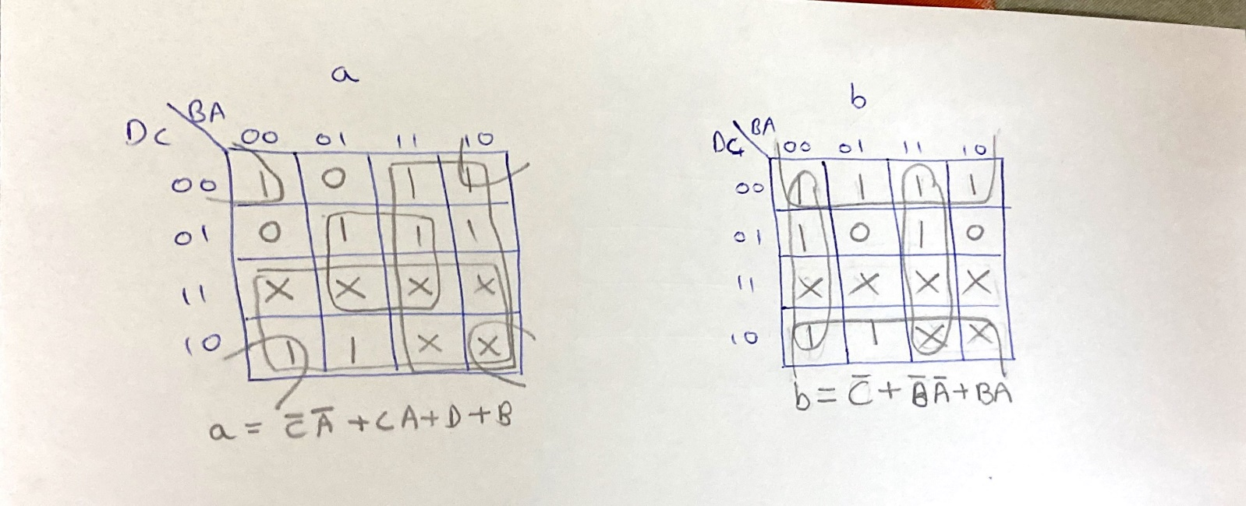
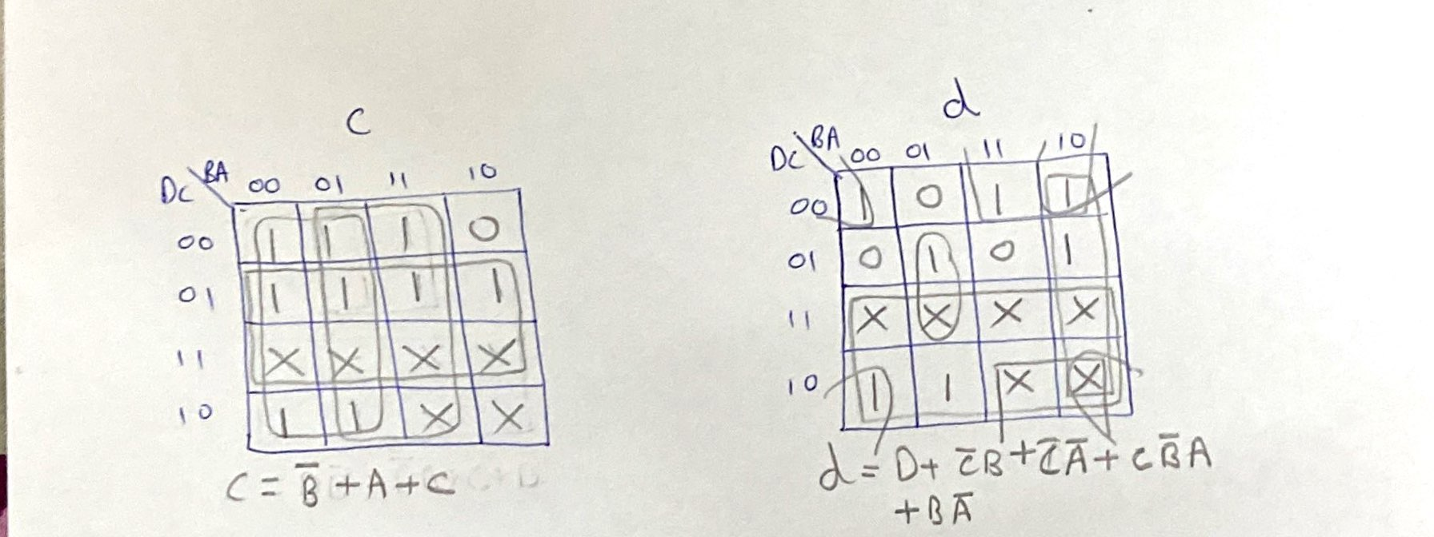
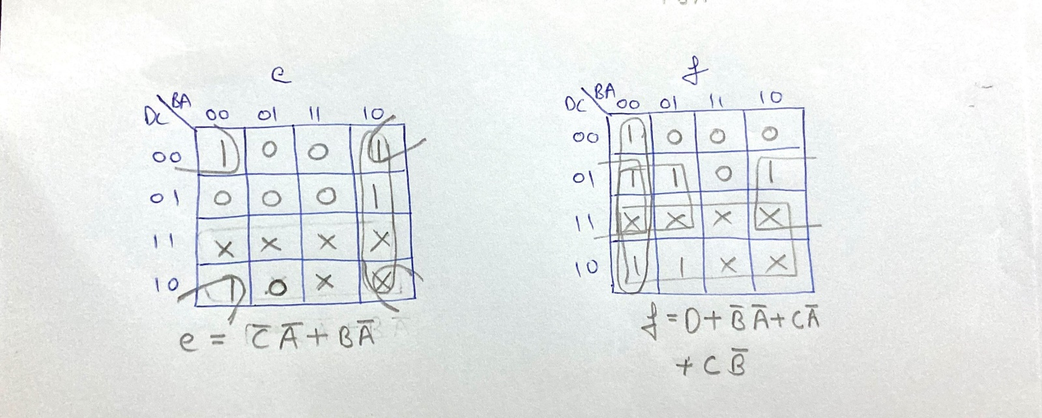
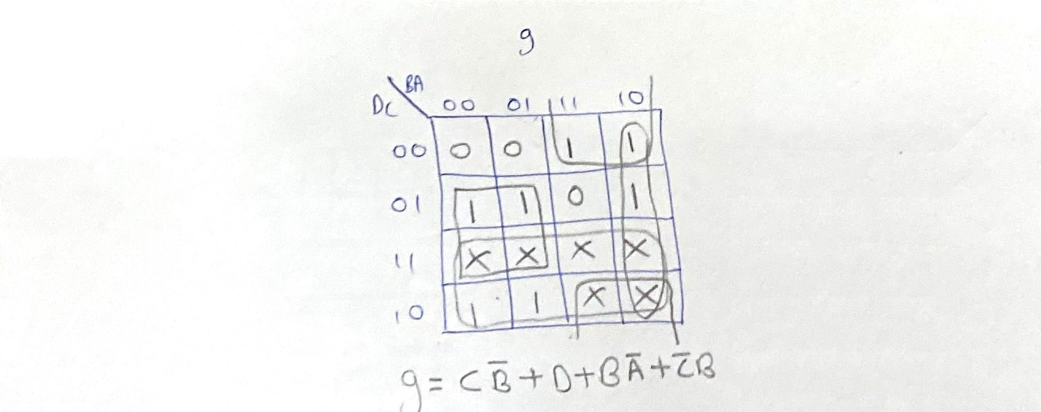

Boolean Expressions: a=C’A’+CA+D+B
b=C’+B’A’+BA
c=B’+A+C
d=D+C’B+C’A’+CB’A+BA’
e=C’A’+BA’
f=D+B’A’+CA’+CB’
g=CB’+D+BA’+C’B
Observation: The decimal number was encoded using the following method:
C3C2C1C0 = 13 – N (in decimal) for 0<=n<=4
C3C2C1C0 = N – 3 (in decimal) for 5<=n<=9
Result: The decoder was successfully designed using 4x1 mux and the output was confirmed using seven segment display.
Application:
It is used in code conversion.For eg from analog to digital.It helps in converting decimal numbers to binary codes which are implemented in electronic circuits.
It is also used in data transmission
Decoders are used as address decoders in CPU memory location identification.

LAB 6(2)
Aim: To design a combinational circuit for dividing a 2-bit number N1 N0 by another 2-bit number D1 D0 and (D1 D0 is not equal to 0) to generate a 2-bit quotient Q1 Q0 and a 2-bit remainder R1 R0.
Components Used:
- Inputs
- NAND gates
- 4x1 MUX
- LEDs
Link for Circuitverse: https://circuitverse.org/simulator/edit/lab6-b-6780061e-03fb-4a25-9d8b-b49657e24184
Circuit Diagram:
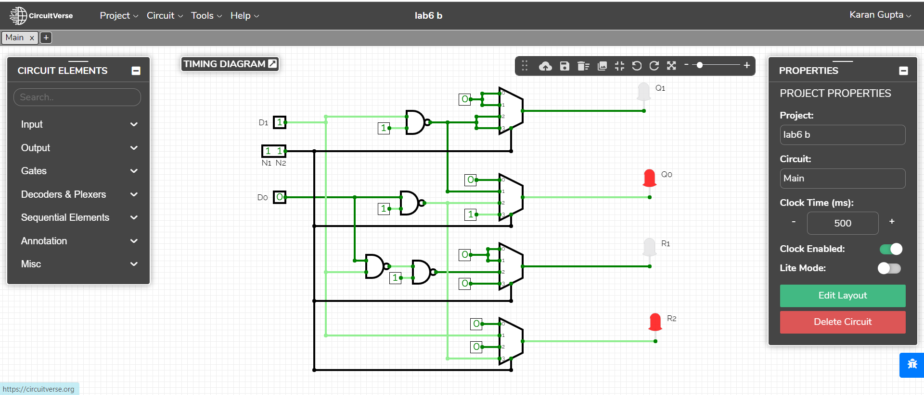
Truth Table:
N1 | N0 | D1 | D0 | Q1 | Q0 | R1 | R0
0 | 0 | 0 | 0 | X | X | X | X
0 | 0 | 0 | 1 | 0 | 0 | 0 | 0
0 | 0 | 1 | 0 | 0 | 0 | 0 | 0
0 | 0 | 1 | 1 | 0 | 0 | 0 | 0
0 | 1 | 0 | 0 | X | X | X | X
0 | 1 | 0 | 1 | 0 | 1 | 0 | 0
0 | 1 | 1 | 0 | 0 | 0 | 0 | 1
0 | 1 | 1 | 1 | 0 | 0 | 0 | 1
1 | 0 | 0 | 0 | X | X | X | X
1 | 0 | 0 | 1 | 1 | 0 | 0 | 0
1 | 0 | 1 | 0 | 0 | 1 | 0 | 0
1 | 0 | 1 | 1 | 0 | 0 | 1 | 0
1 | 1 | 0 | 0 | X | X | X | X
1 | 1 | 0 | 1 | 1 | 1 | 0 | 0
1 | 1 | 1 | 0 | 0 | 1 | 0 | 1
1 | 1 | 1 | 1 | 0 | 1 | 0 | 0

KMaps:
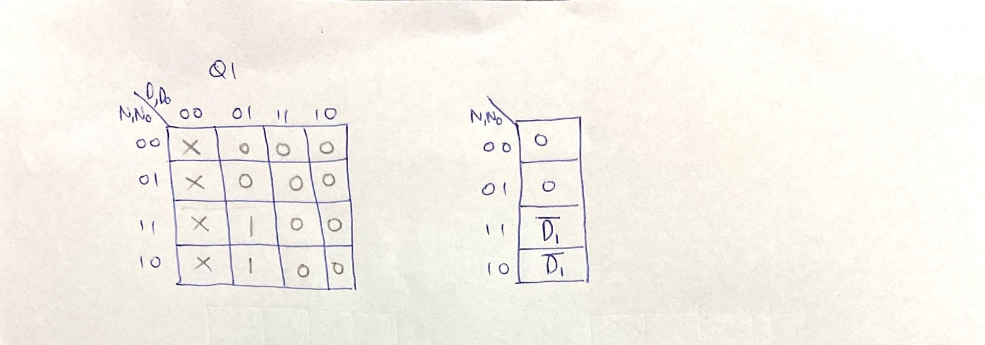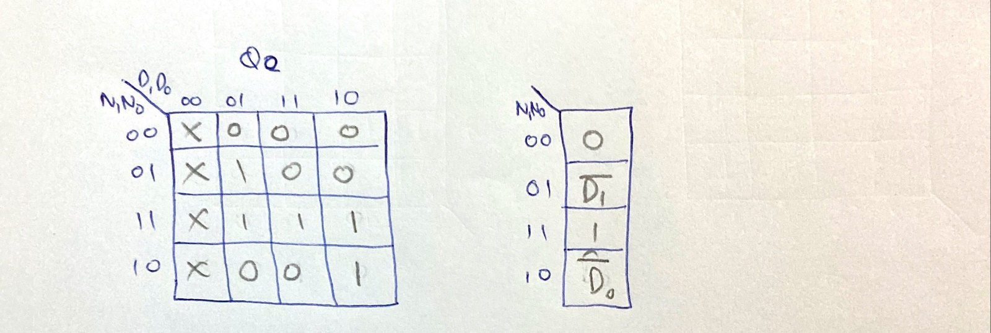
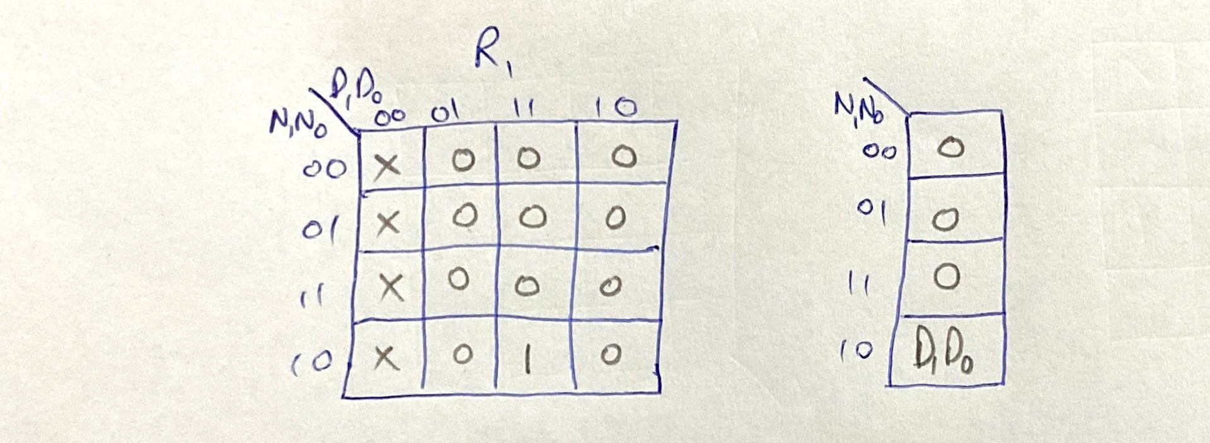
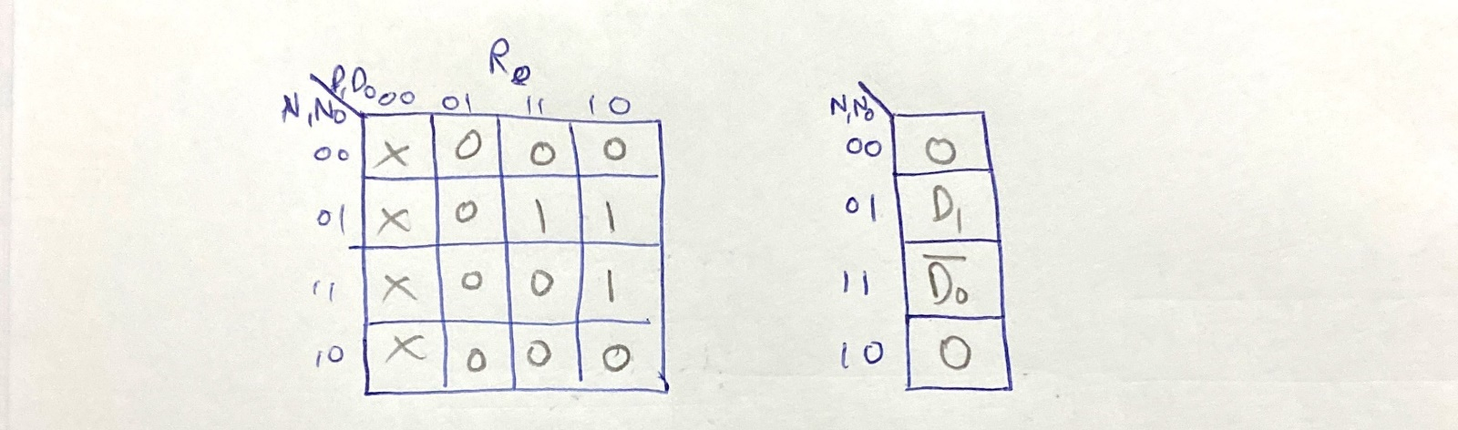
Boolean Expression:
Q1=N1.N0.D1’+N1.N0’.D1’
Q0=N1’.N0.D1’+N1.N0+N1.N0’.D0’
R1=N1.N0’.D1.D0
R0=N1’.N0.D1+N1.N0.D0’
Observation:The truth table was verified using the divider circuit.
Result:The 2-bit division circuit was implemented successfully.
Application:
It is used in ALU for division operations

